

**TRANSFORMING LIMITING BELIEFS**

**STEP 1: THE EMOTIONAL GAUGE**

A thought weed, is simply a limiting belief or a story we tell ourselves that limits us in some way. It could produce negative feelings, stop us from trying something, or even prevent us from living our deepest purpose and highest potential. When we plant a mind seed, that is a more resourceful belief or a story that produces much better feelings, instills courage, tenacity, and frees us to live our purpose. This worksheet walks you through the first step, of four, for how to plant new more resourceful beliefs

It all begins by paying attention to one simple thing. How you feel?

Consider the metaphor of the gas gauge in your car. When it’s running low, it is simply telling you to fill it up. Our emotional life presents a similar spectrum, your emotional gauge could be depicted like this:

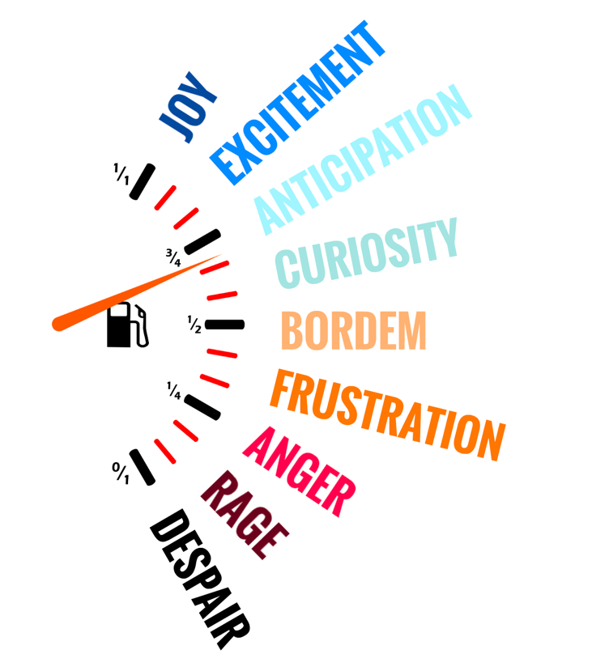

When we understand that our negative emotions are just as important as our positive ones, we can begin to see them more clearly.

So the first question you want to ask yourself is, what am I feeling?

**ENERGY IN MOTION**

How do you know you are feeling what you are feeling? What information do you have that indicates you are bored or stressed, sad, or angry? All emotion is just energy in motion. One way to detect your emotions is to simply do a body scan. Notice what sensations are occurring in your body and begin to map the energies. This helps us become more aware of what is happening. It also helps us take something like a feeling, which is amorphous and difficult to nail down, and only happens in time (“I’ve been angry the past three days”) and brings it into space.

Here’s what I mean, when you detect and locate and emotion in your physical body you give it spatial dimension. That means you are adding dimensions and definition to the feeling (time is technically only half a dimension- it only moves in one direction, not even backwards. Space is of course three dimensions). Why is this important? When you can see something more clearly with greater definition and understanding, you can begin to transcend it and direct it rather than just be a victim of it. Our feelings guide us, but we can in-turn guide them too.

Take a situation in your life you’re not happy with and notice what you are feeling. Now do a body scan and begin to ask yourself these questions about that feeling?

1. Where is it located in your body? (legs, chest, pelvis, shoulders, ears, etc.)
2. What shape is it? (ball, mass, star, rectangle, splinter, sheet, cloud)
3. How big is it? (Watermelon, golf ball, baseball, etc)
4. Is it moving or changing? (is it rising, falling, growing, vibrating, sitting dead still, etc.)
5. How deep is it? (at the surface of the skin, muscles, organs, etc)
6. Does it have a texture? (smooth, spikey, soft, divets, sandpaper, electrified, etc.)
7. Does it have mass? (Is it heavy and dense, or diffuse and empty, is it like liquid, solid, or gas, etc)
8. Does it have a color? (grey, black, green, blue, yellow, etc.)
9. Has it changed since you started observing and naming it? (Grown, shrunk, moved, changed shape, etc.)

Just by asking these questions and observing your emotion, without trying to change anything, you are giving it shape and making it more manageable. You are also, without knowing it, affecting it. You may notice as you observe and describe the feeling it will undergo transformation and changes. Just notice for now what happens in your body.

This practice is designed to advance your awareness of the inner life, making more parts of you more conscious. When you have more emotions available, you have much better guidance.