

**TRIPWIRES WORKSHEET**

Tripwires are our values or vulnerabilities that, when violated, trigger us into reactive and emotionally state. Understanding these and naming them help us understand how and why conversations may go wrong.

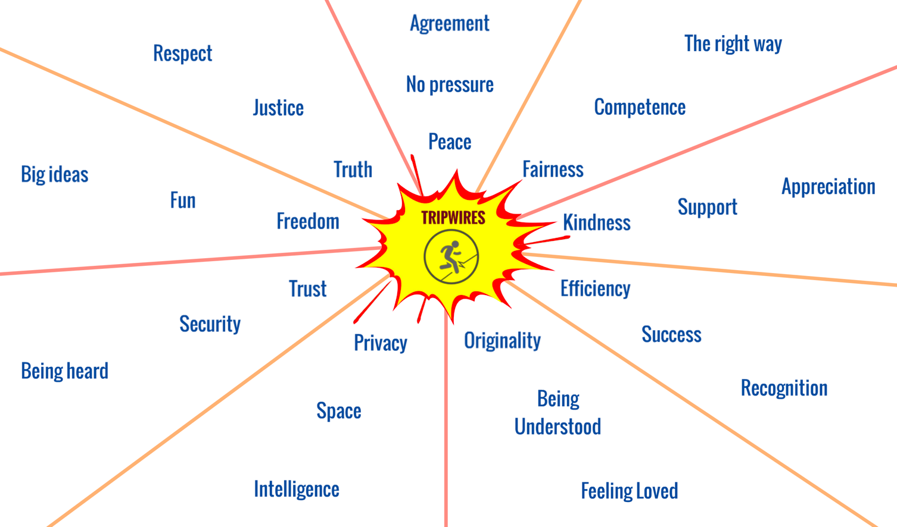

1. What are your Tripwires?