

**INSIDE OUT WORKSHEET**

**FEELINGS**

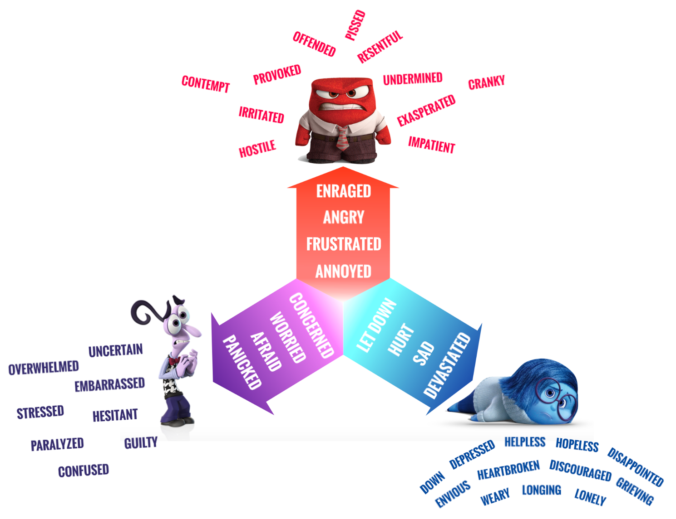

1. What feelings do you bring to this conversation?