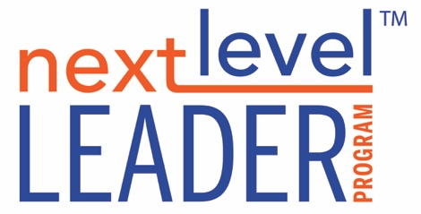

**CONVERSATIONAL STYLES WORKSHEET**

We all have a conversational style, particularly when it comes to having hard conversations. We tend to live on two spectrums, the speed or urgency in which we want to talk (talk now or talk later), and the manner in which we talk (talk straight or talk around).

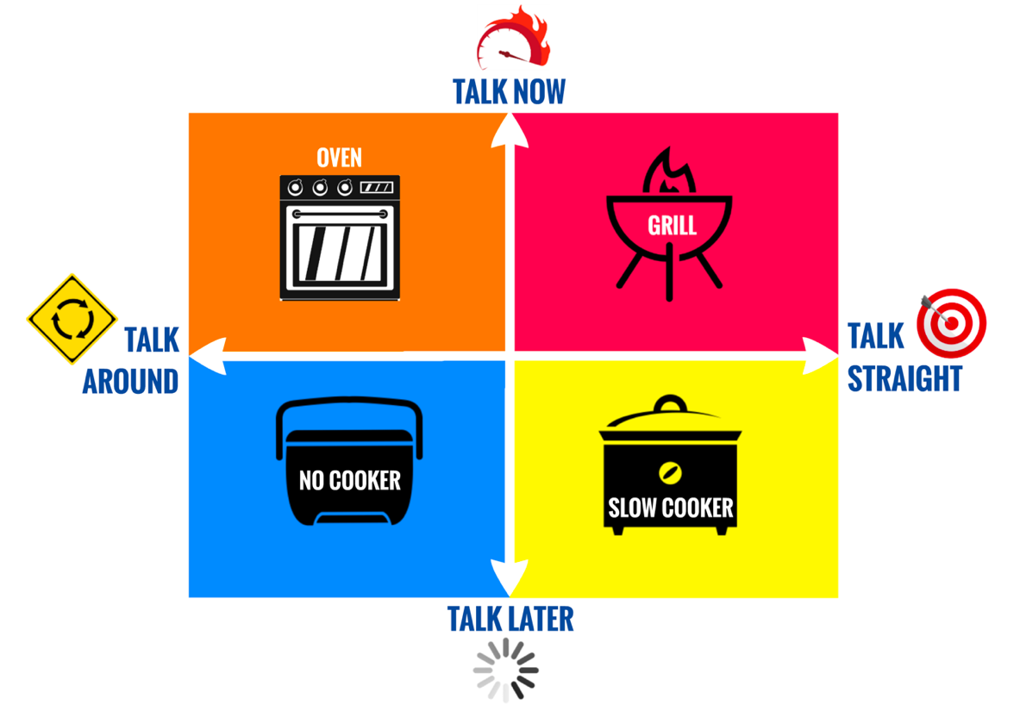

1. Which style do you operate from most often?
2. Has this ever changed? If so, which did you used to prefer?
3. What caused the change?
4. Do you tend to resist any one of these more than another? If so, what a reason?
5. Is there one you feel you need to stretch into?