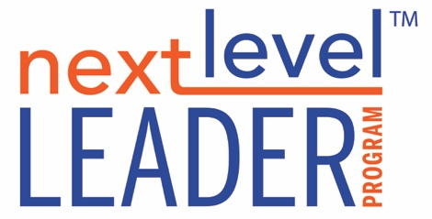

**THE UNSEEN SELF WORKSHEET**

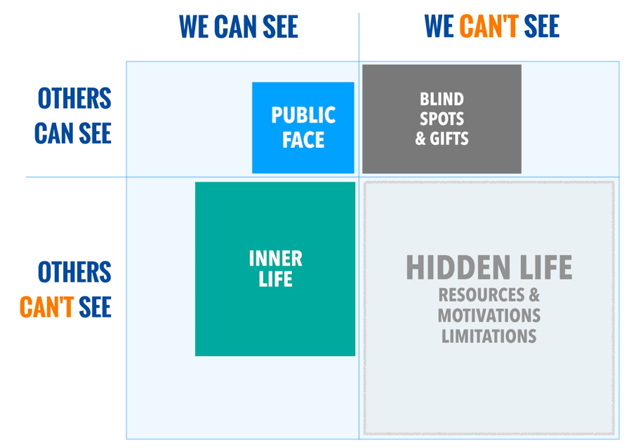

**BLIND SPOTS & GIFTS**

1. What affect did it have when someone observed a flaw in you that you didn’t see?
2. What was the impact when someone observed a gift in you that you didn’t recognize?

**INNER LIFE**

1. What kinds of things do you tend to withhold sharing with others?
2. How might it serve others for you to reveal things you normally withhold?

**HIDDEN LIFE**

1. When was the last time you discovered something about yourself that you didn’t know (and neither did anyone else)? What did you discover?