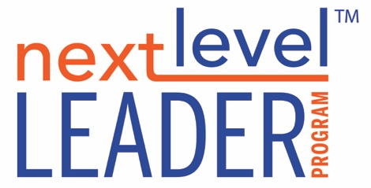

**A BEGINNER’S MIND WORKSHEET**

**THE TWO SELVES**



**Solid Self:**

Complete the statements below*. What are you clear about in yourself? Consider noting important values or beliefs, or traits and tendencies. These are things you currently are (i.e. I am direct and no nonsense, or I am someone who dislikes conflict, or I am not an operational person. Etc.).*

1. **I AM…**
2. **I am NOT…**



**Changing Self:**

Complete these statements below*. What might be emerging in you? What skills or capacities are the situations in your life or work calling forth from you?*

1. **I am becoming more…**
2. **I’m interested to learn…**
3. **I am becoming less…**